Make it Monday
Craft Club
Week 1
Glass jars decorating

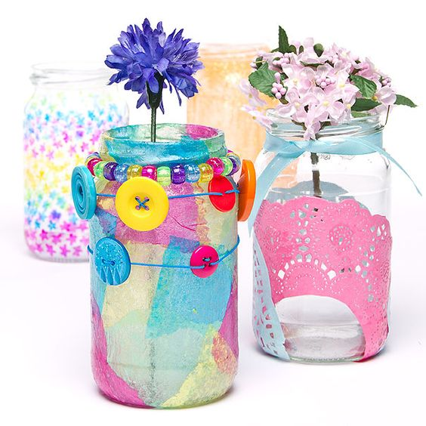
Week 2
Scrap booking
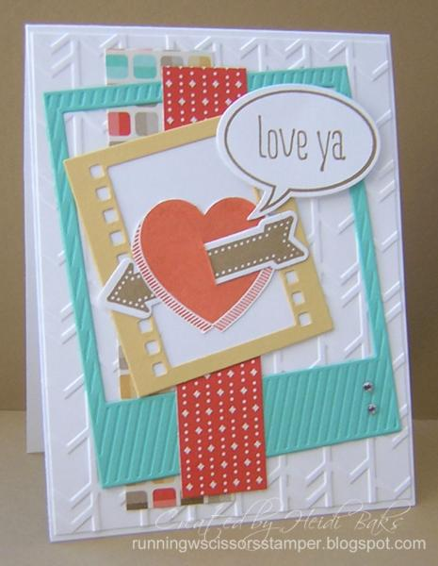
Week 3
Dream catchers 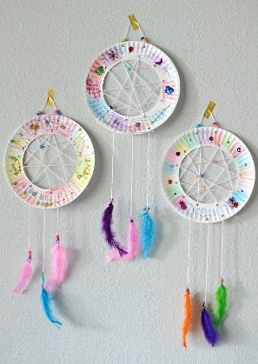

Week 4
Note book and pencil
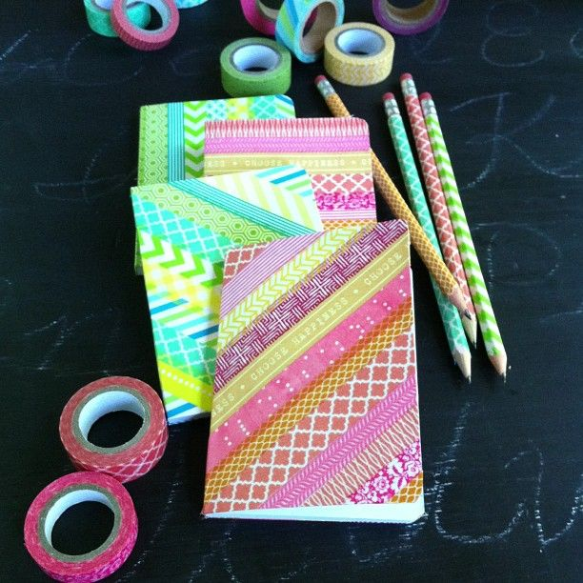
Week 5
washi tape picture
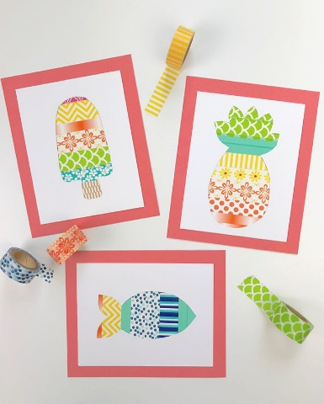
Week 6
Pencil decorating
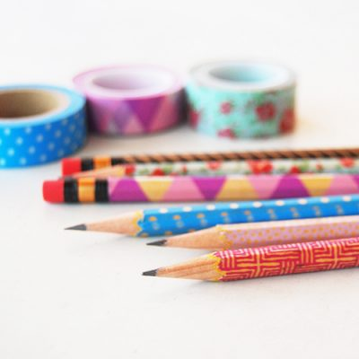

Week 7
Flower frame
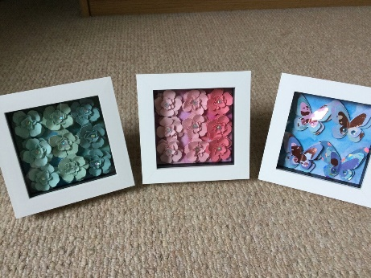
See
you next term!

