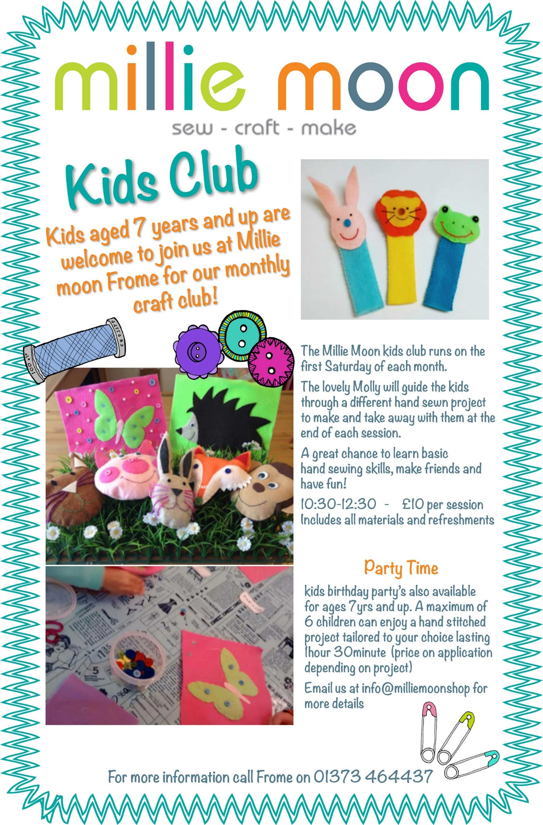

Now offer new activity clubs providing broader curriculum learning activities every day after school.
Children aged 5 and up are welcome to join us in our daily clubs!



Miss Houghton and her team
will help you to develop new skills in a secure, friendly environment.

Each day has a diffident theme, including Making Monday - Crafty Club
Tasty Tuesday - Cooking Club
Workout Wednesdays – Keep Fit Club
Techno Thursdays - Science Club
Fresh air Fridays – Nature Club.

All our clubs run every day term time from 3.15pm - 4.45pm from KS2
Home time Pick up KS2 Gate 2
gate 2
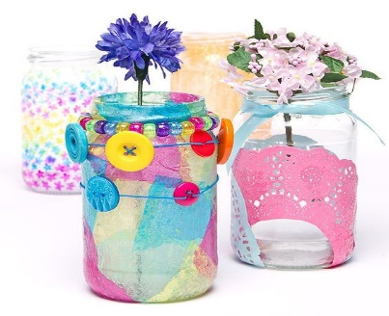
Crafty Kids is an independent privately business
We work in partnership with Our Lady’s Catholic Primary School
For more information visit our web page www.craftykidsasc.co.uk
Or text Miss Houghton on 07703185750
Make - Explore - Taste – Enjoy
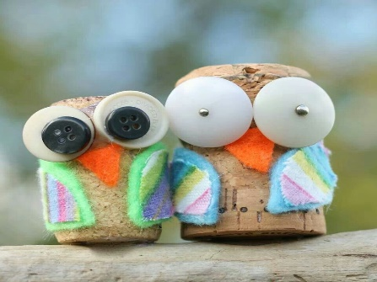
Cost is £4.50 per day paid in advance this includes snack and all materials.
See our webpage for daily activities


To book a place complete a registration form and booking form

A great chance to improve kinetic skills, make friends and have fun!

Crafty Kids 

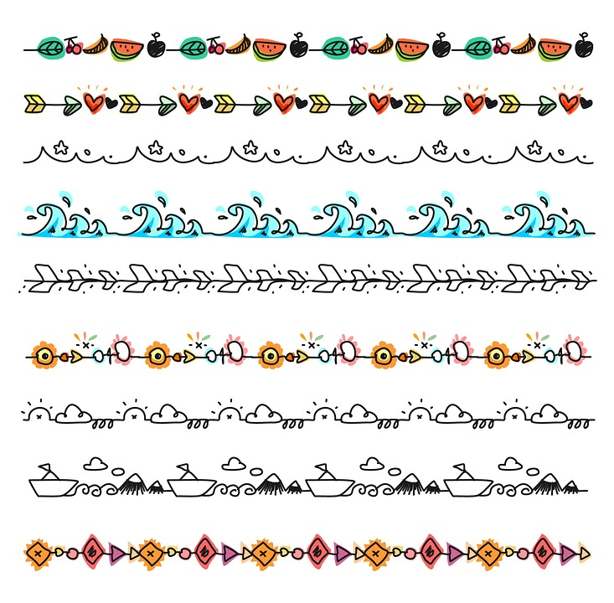

New Crafty Kids November /December 2021 Booking Form
CO Our Lady's Catholic Primary School Wellingborough Northants NN82BE
Crafty Kids Direct Telephone Number 07703185750 Activities Website www.craftykidsasc.co.uk

Childs Full Name…………………………………………………………………………………………………………. Class ………

You will need to complete this booking & registration form and make payment to guarantee your child(s) place

MONDAY   | Make it Mondays  Week 1  Nov 1st |  | Make it Mondays  Week 2  Nov 8th |  | Make it  Mondays  Week 3  Nov 15th |  | Make it  Mondays  Week 4  Nov 22nd |  | Make it  Mondays  Week 5  Nov 29th |  | Make it  Mondays  Week 6  Dec 6th |  | Make it  Mondays  Week 7  Dec 13th
TUESDAY   | Tasty Tuesdays  Week 1  Nov 2nd |  | Tasty Tuesdays  Week 2  Nov 9th |  | Tasty Tuesdays  Week 3  Nov 16th |  | Tasty Tuesdays  Week 4  Nov 23rd |  | Tasty Tuesdays  Week 5  Nov 30th |  | Tasty Tuesdays  Week 6  Dec 7th |  | Tasty Tuesdays  Week 6  Dec 14th
WEDNESDAY   | World  Wednesday  Week 1  Nov 3rd |  | World  Wednesday  Week 2  Nov 10th |  | World  Wednesday  Week 3  Nov 17th |  | World  Wednesday  Week 4  Nov 24th |  | World  Wednesday  Week 5  Dec 1st |  | World  Wednesday  Week 6  Dec 8th |  | World  Wednesday  Week 7  Dec 15th
THURSDAY   | Thinking  Thursday  Week 1  Nov 4th |  | Thinking  Thursday  Week 2  Nov 11th |  | Thinking  Thursday  Week 3  Nov 18th |  | Thinking  Thursday  Week 4  Nov 25th |  | Thinking  Thursday  Week 5  Dec 2nd |  | Thinking  Thursday  Week 6  Dec 9th |  | Thinking  Thursday  Week 7  Dec 16th
FRIDAY   | Fresh Air Fridays  Week 1  Nov 5th |  | Fresh Air Fridays  Week 2  Nov 12th |  | Fresh Air Fridays  Week 3  Non 19th |  | Fresh Air Fridays  Week 4  Nov 26th |  | Fresh Air Fridays  Week 5  Dec 3rd |  | Fresh Air Fridays  Week 6  Dec 10th |  | Fresh Air Fridays  Week 6  Dec 17th

Total club 3.15pm—4.45pm ____________@£4.50 Total To Pay £______________________
Payments Methods .
Childcare voucher: You need to make sure we are registered with your provider AND use your child’s name as
reference
BACS Starling Crafty Kids (Angela Houghton) Sort Code 60-83-71 Account Number 96811074

Crafty Kids School Money use your own personal login details(N0t the school account)
Signed …………………………………………………………… Date …………………………………….

Emergency Mobile number …………………………………………………………………………...Please return your registration form asap

