Tasty Tuesday

Cooking club
Week 1
Hedgehog bread

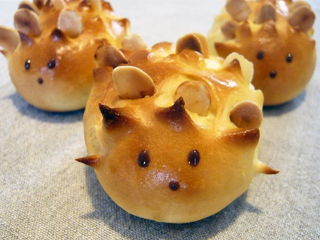
Week 2
Fruit salad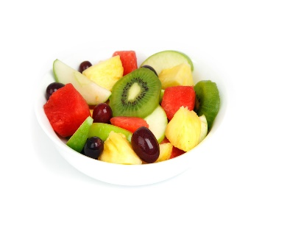
Week 3
Pizza


Week 4
Crispi cake


Week 5
Face biscuits
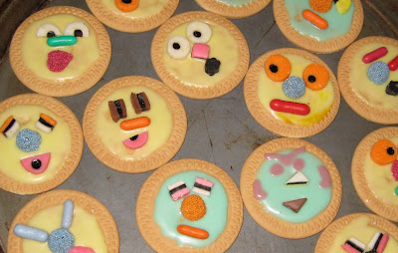
Week 6 chocolate apples

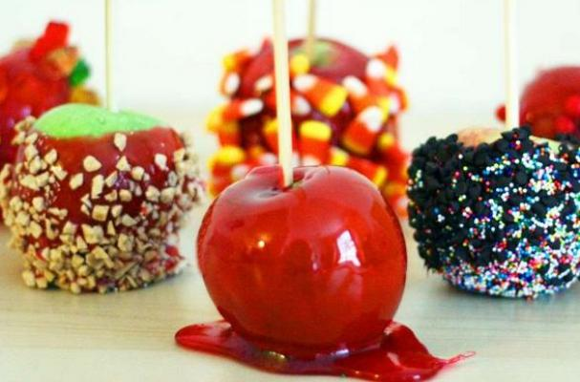

Week 7
Cup cakes

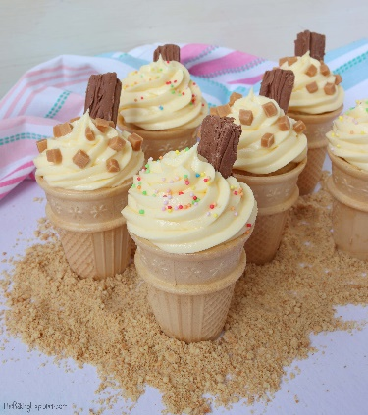

See
you next term

