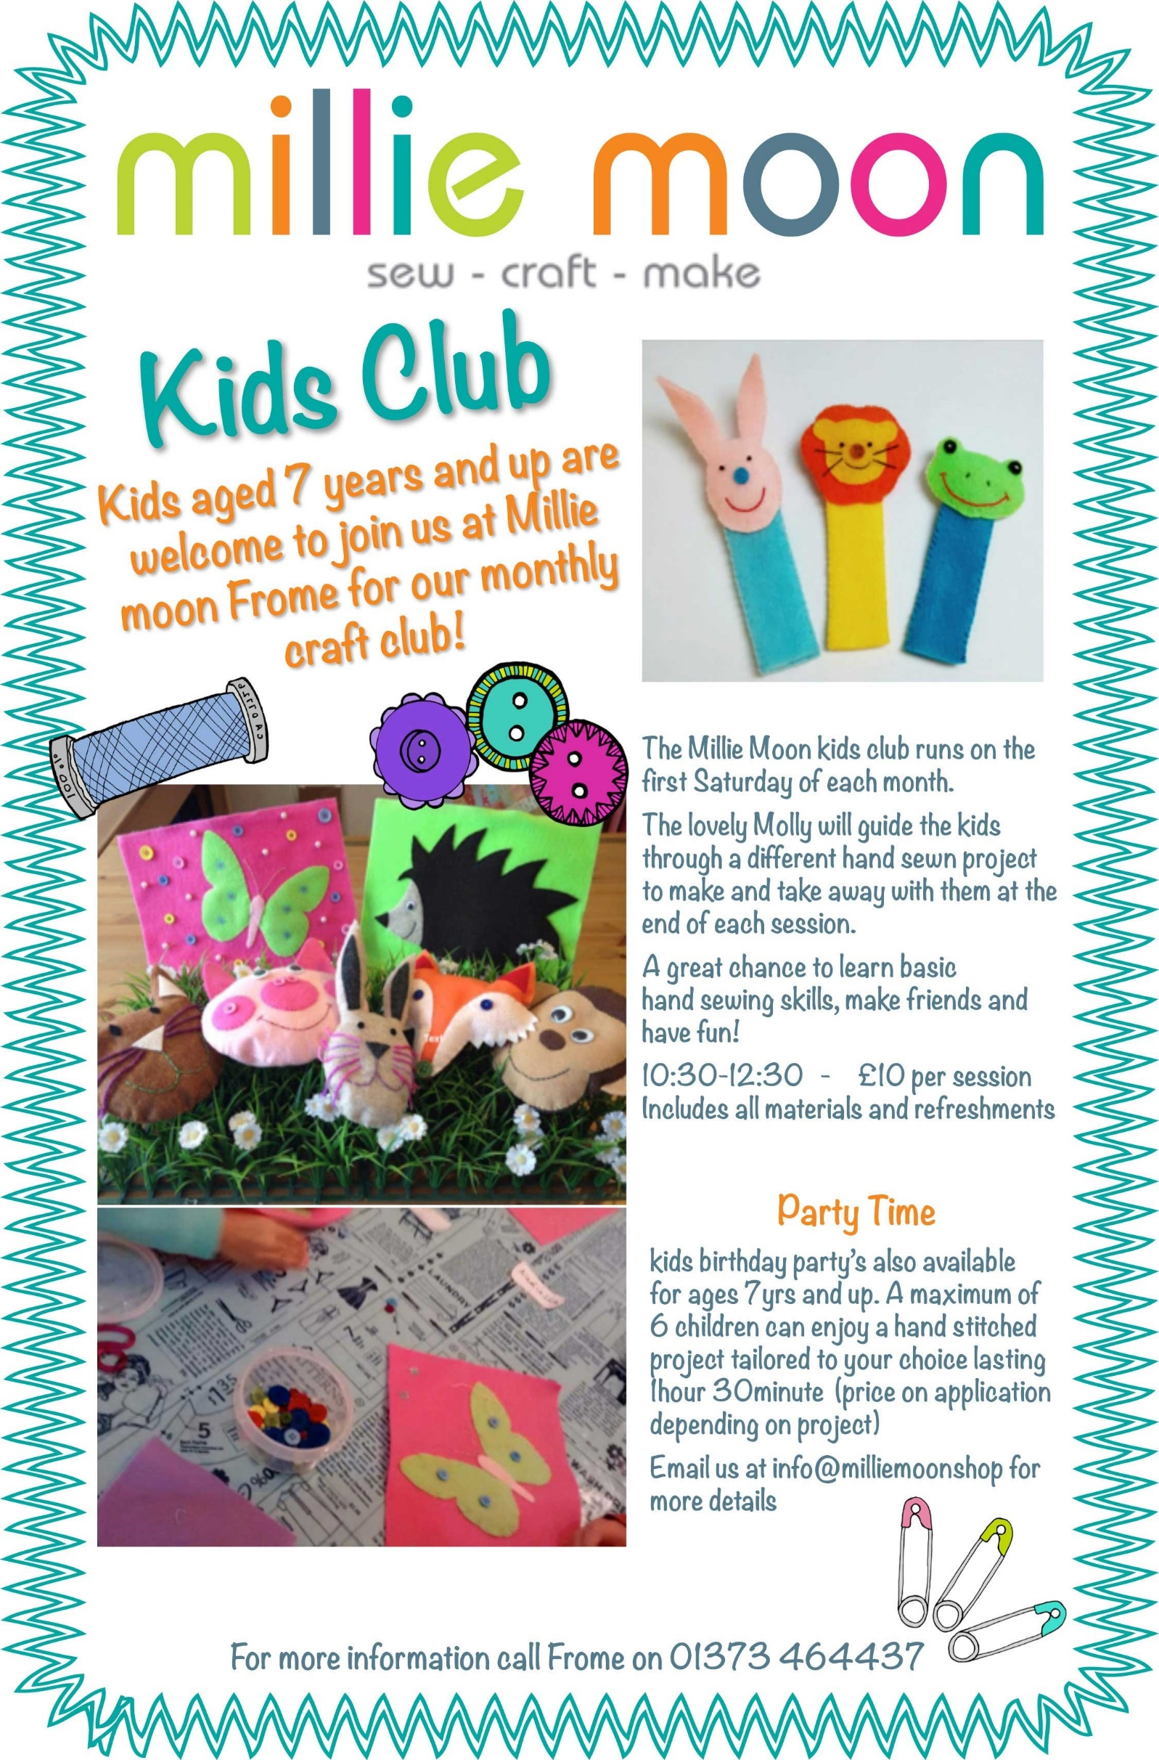
Make - Explore - Taste – Enjoy

Miss Houghton and her team
will help you to develop new skills in a secure, friendly environment.
Each day has a diffident theme, including Making Monday - Crafty Club 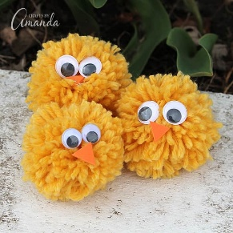
Tasty Tuesday - Cooking Club 
Wednesday – multi skills Club 
Thursday – Story activity Club 
Fresh air Fridays – Nature Club. 


Cost is £4.50 per day paid in advance this includes snack and all materials.
A great chance to improve kinetic skills, make friends and have fun!

To book a place complete a registration form and booking form
Crafty Kids is an independent privately business
We work in partnership with Our Lady’s Catholic Primary School

For more information visit our web page www.craftykidsasc.co.uk
Or text Miss Houghton on 07753609076
All our clubs run every day term time from 3.15pm - 4.45pm
Home time Pick up KS2 Gate 2
Now offer new activity clubs providing broader curriculum learning activities every day after school.
Children aged 5 and up are welcome to join us in our daily clubs!

Crafty Kids 

